Week 6

Q.1). Create a NumPy array and compute mean, median, and standard deviation of its data.
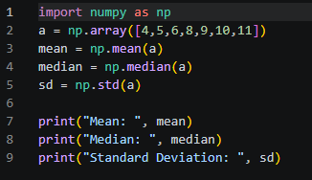
Output
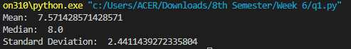
Q.2). Perform matrix addition and multiplication using NumPy.
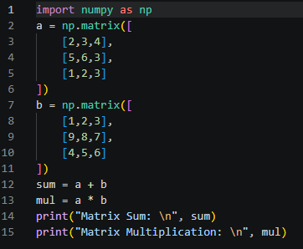
Output
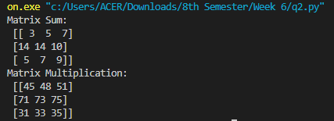
Q.3). Generate a random array and find its maximum and minimum values.
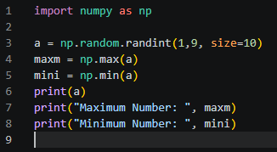
Output
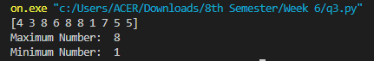
Q.4). Reshape a one-dimensional array into a matrix of different sizes
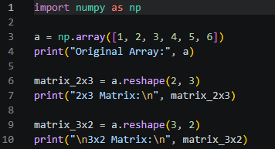
Output
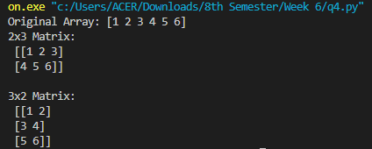

Problems based on HTML and JavaScript
Q.5). Design a Web Page, which is like ‘compose’ page of e-mail
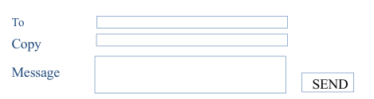
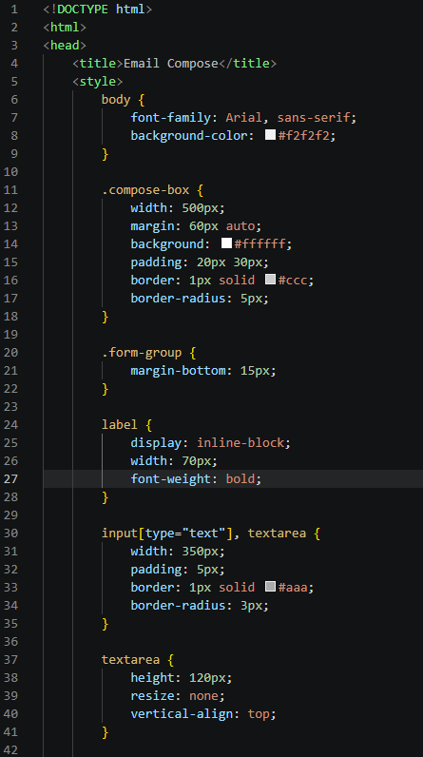
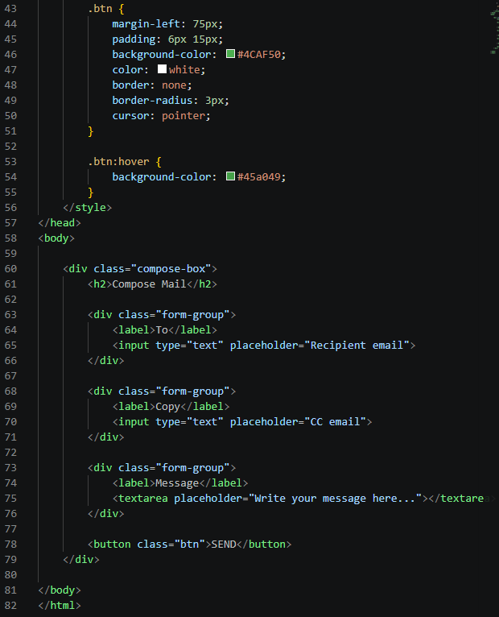
Output
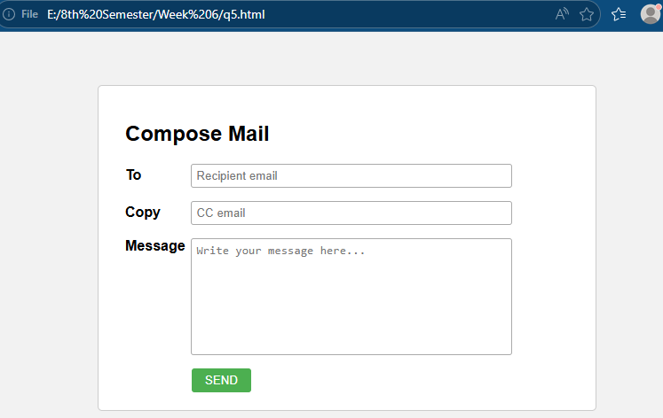

Q.6). Design a series of three HTML Pages for ABC.COM, each called from the previous one. Accept Name on the first page. When the user clicks on the enter button, second page should open. The second page should not display the name but a ‘Welcome screen with some information about ABC.COM. When the user will click on the ‘next’ button it should display the name accepted in page 1 on page 3. (Hint: you may use hidden fields)
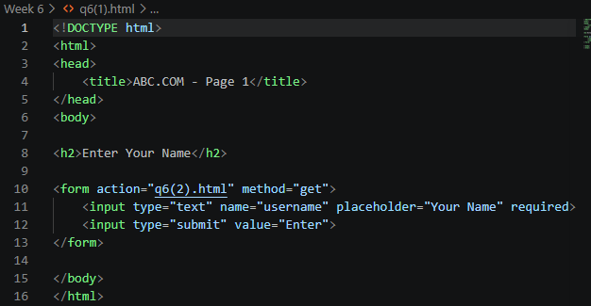
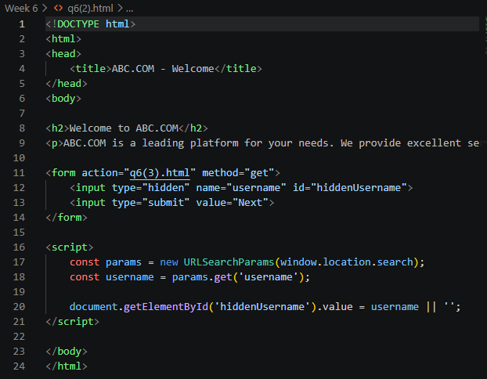
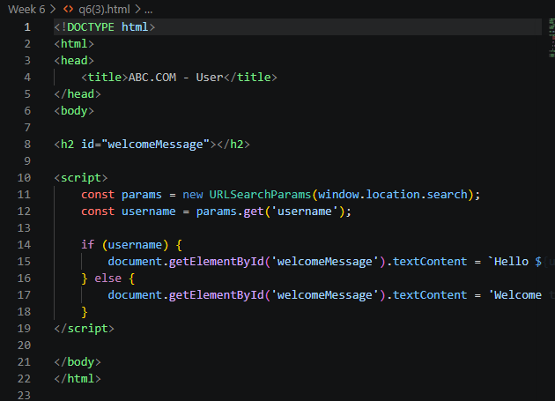
Output
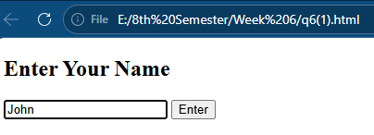
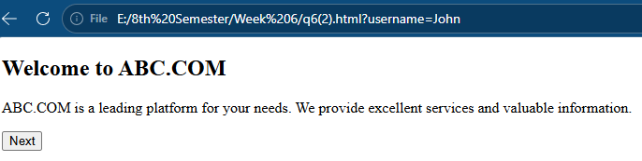
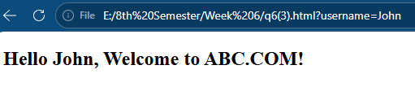
Q.7). Write the segment of Script that would ask the user if he wants a greeting message and if he does, display a Gif file called Welcome.gif and display “Welcome to Department of Computer Science!” in the document window following the Gif.
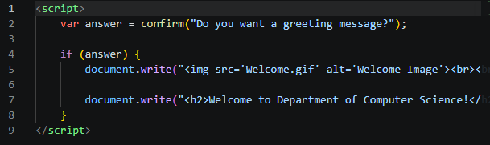
Output
